Band 7
The chart below shows the number of households in the US by their annual ’ income in 2007, 2011 and 2015.
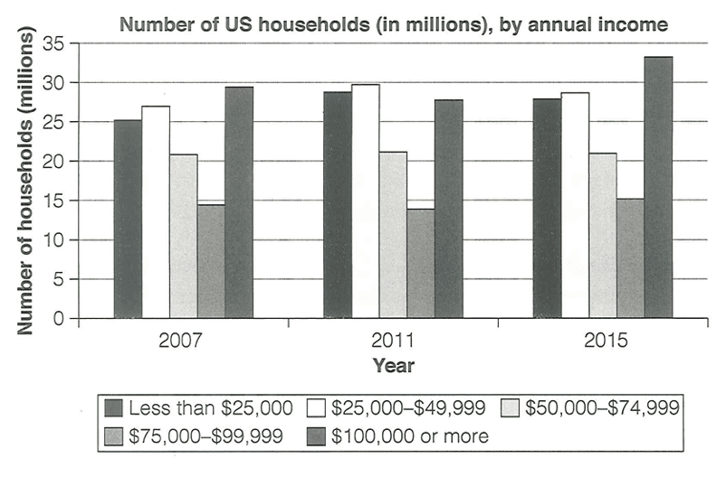
The provided chart illustrates statistical insights related to the annual income of US residents in 2007, 2011, and 2015.
Overall, it is evident that a significant number of households in all three time periods earned more than $100,000 per year. This is followed by households that earned less than a quarter of a million during the year, which also contributed a considerable amount.
A detailed observation indicates that, approximately 22 million US households earned less than $25,000 in 2017, but by the time this figure increased and more than 27 million people were belonging to this category in 2011 and 2015. In contrast, individuals who had a yearly income from $25,000 to $49,999 followed a similar pattern as the previous one; it started at 23 million and ended at 28 million. Subsequently, 22 million people had an annual income from $50,000 to $74,9999, and this remained unchanged throughout all three-time intervals.
At the penultimate stage, about 15 million citizen who had an annual income from $75,999 to $99,000 experienced minor changes, but it could be considered stable. In comparison to this, more than 35 million household earned $100,000 or more money over the year; this trend experienced unprecedented fluctuation over time. In 2007, 29 million, in 2011, 26 million, and in 2015, the number of households reached its peak with more than 37 million.

